**Tile set research/trial and error**

Sizing (powers of 2)

Before considering anything else, the standard element size needed to be determined. This influences every asset needed for this project, so it has to be nailed down before anything is made. Traditionally, the size of tiles/elements follow 2^x – 16px by 16 px, 32px by 32px, and so on – due to storage limitations of earlier technology.

This isn’t a concern anymore, and realistically, Unity can take any number of untraditional sized graphics just as easily (even rectangle instead of square tiles). As an artist, however, squares are easier to tile, and give the smaller scale of our screen, the smaller the tiles can be while being well readable, the more complex we can make our environments without losing detail.

After discussing with the group, I decided on the traditional proportion of 16px by 16px for our tiles. In addition to the tiles themselves, any other designs must fit within these constraints. This doesn’t mean a character should be 16x16, but it should fit in some multiple of this. The current character mockup fits inside 16x32, or two tiles stacked vertically.

Side scroller tiles vs. top down tiles

My previous experience in making tile sets was with front facing side scroller type graphics. A lot of skill carries over, but for top down, there are more dimensions to think about. It visually acts less like a flat 2D space.

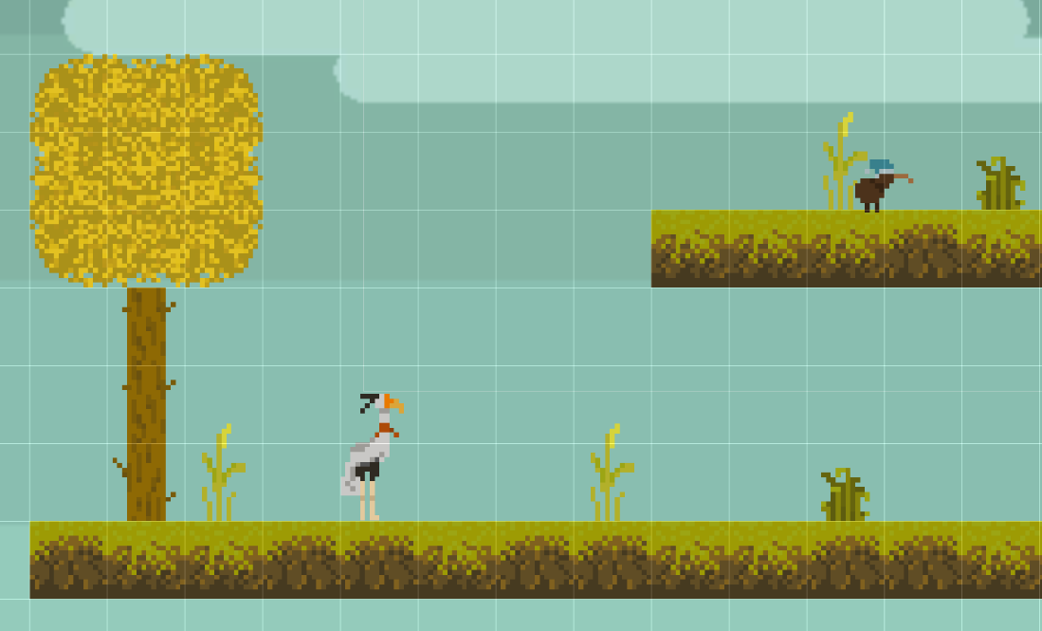

Going in without reference would not be an effective way to work, and as the lead on graphics and aesthetic for this project, it was important to do the leg work to nail down a cohesive look to work from in the future.

There are two existing games, both very successful in the procedural dungeon crawler genre, I looked to for inspiration.

Enter the Gungeon: Binding of Isaac:

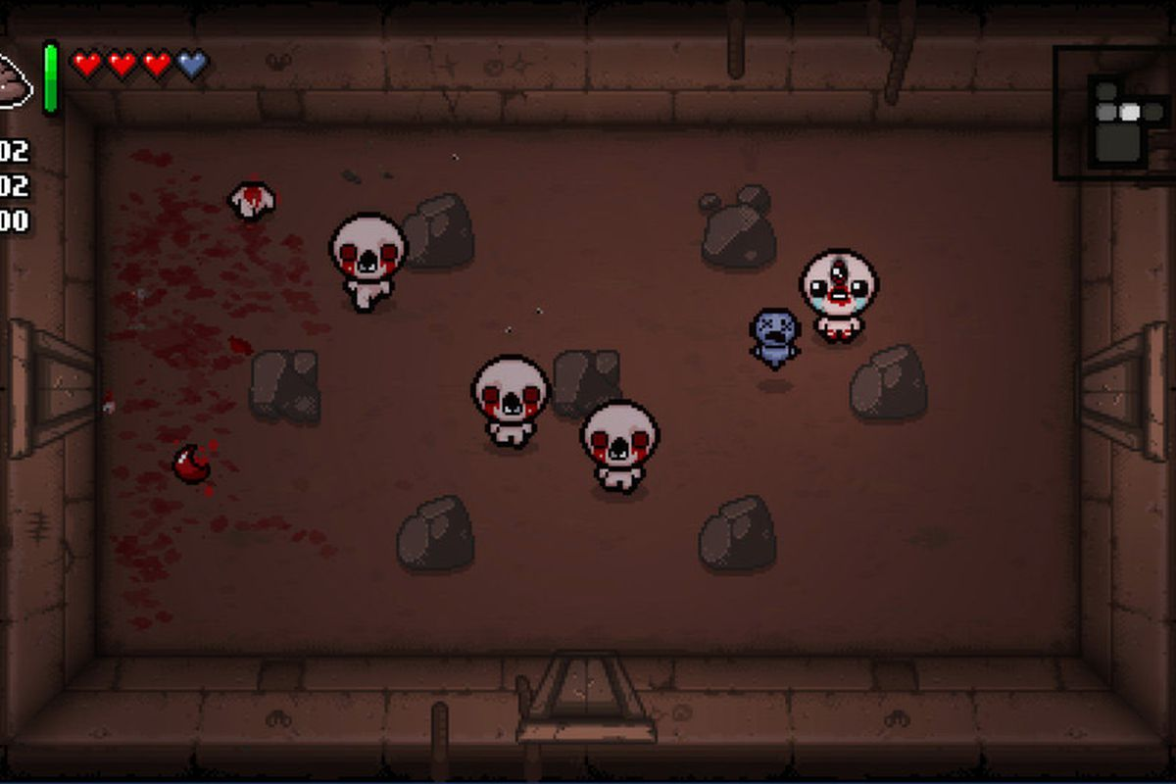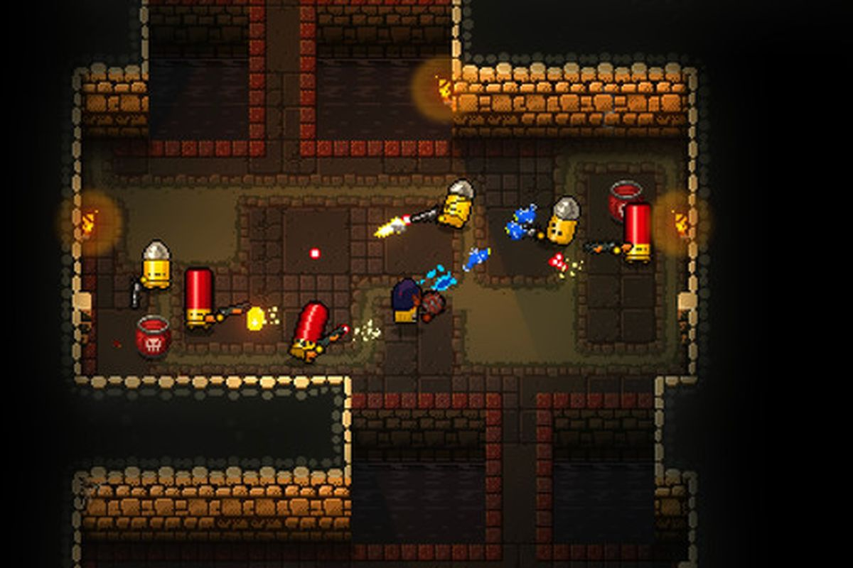

The first decision that needed to be made was how to handle perspective.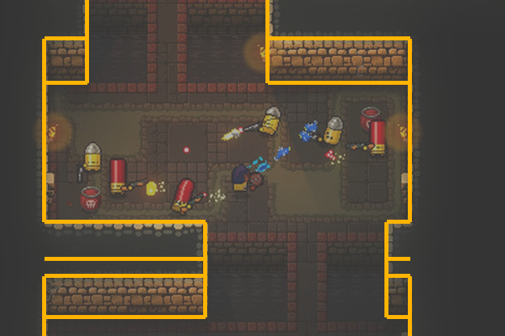

In Enter the Gungeon, the camera is tilted to look down at the room at an angle, allowing the player to see one plane of walls at a time. There is no vanishing point. This map perspective is ideal for a camera that moves with the player, allowing for more complex exploration of randomly generated rooms.

The main con to this style is how doors need to be handled. If a door appears on the north wall, it can be a regular pixel asset, but there are no other truly visible walls. There are assets for side and South walls, but they are from the player’s perspective, not the playable character’s. To create a door in this layout, a cutout would have to be taken from the null space outside the created dungeon.

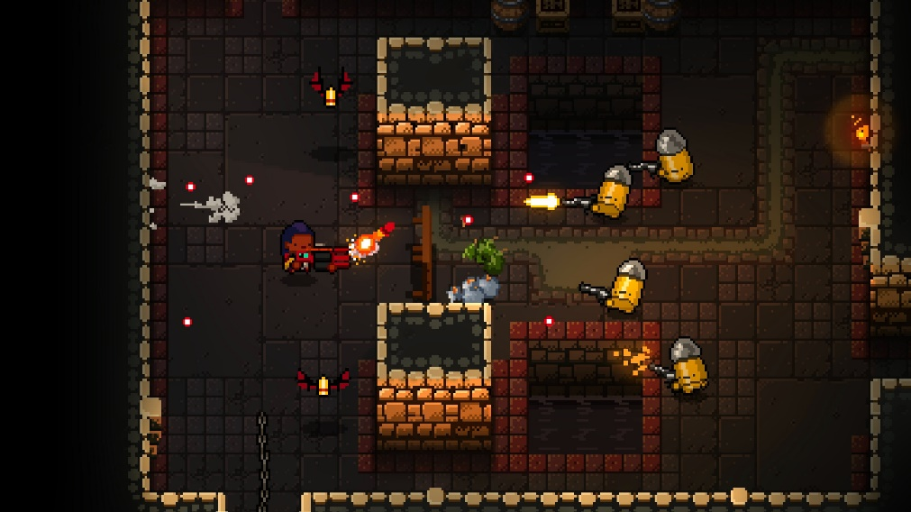

Again, this works for a dynamic camera that moves with the character. The null space is often visible, so a small cut out from a door is no issue. For us, however, the movement of a character in Touchcrawler is purely touch based on a mobile device. This gives us fewer options when it comes to control scemes.

A dynamic camera will make touch controls less precise, so that isn’t an option. This means each room must be a set size to be fully visible on the screen of a mobile device (let’s assume phone). This makes screen real estate a commodity, and knowing doors can’t only be on the North wall, any bump outs for doors would make that real estate smaller, introducing a strip of null space into the camera view. It could be made to work, but this view is not an ideal view scheme for our graphics.

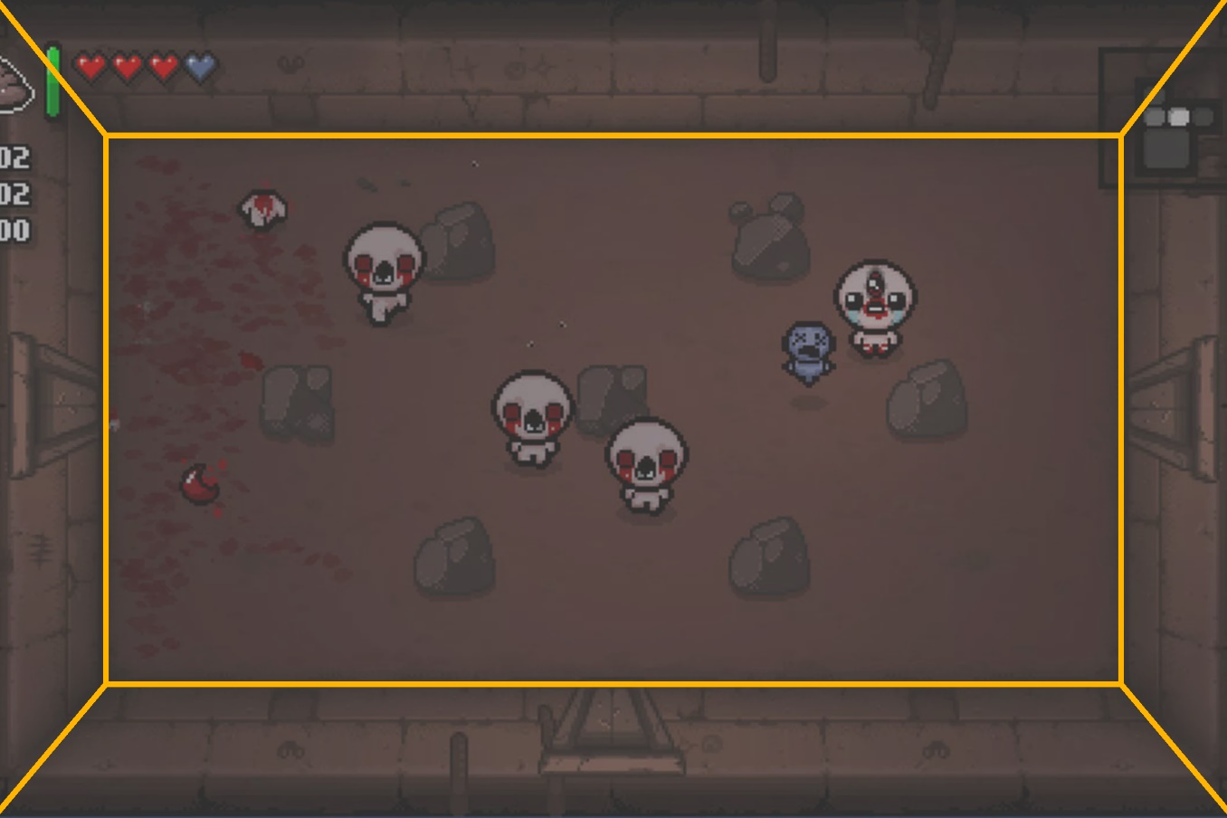

In Binding of Isaac, the player is given a top down view with a vanishing point in the middle of the screen – this means all vertical lines in the 3D space would be pulled to this point. This gives the player a clear view of every wall, eliminating the need for null space around doors not found in the North wall.

While there are a variety of room shapes and sizes in Binding of Isaac, aided again by its dynamic camera, the room pictured above is an ideal setup for a touch-based mobile game. A touch input would have a clear position to the player no matter the player’s current movement, and what could be considered lost game space at the base of the screen can be utilized as toolbar or UI space. This is closer to the view scheme I went with.

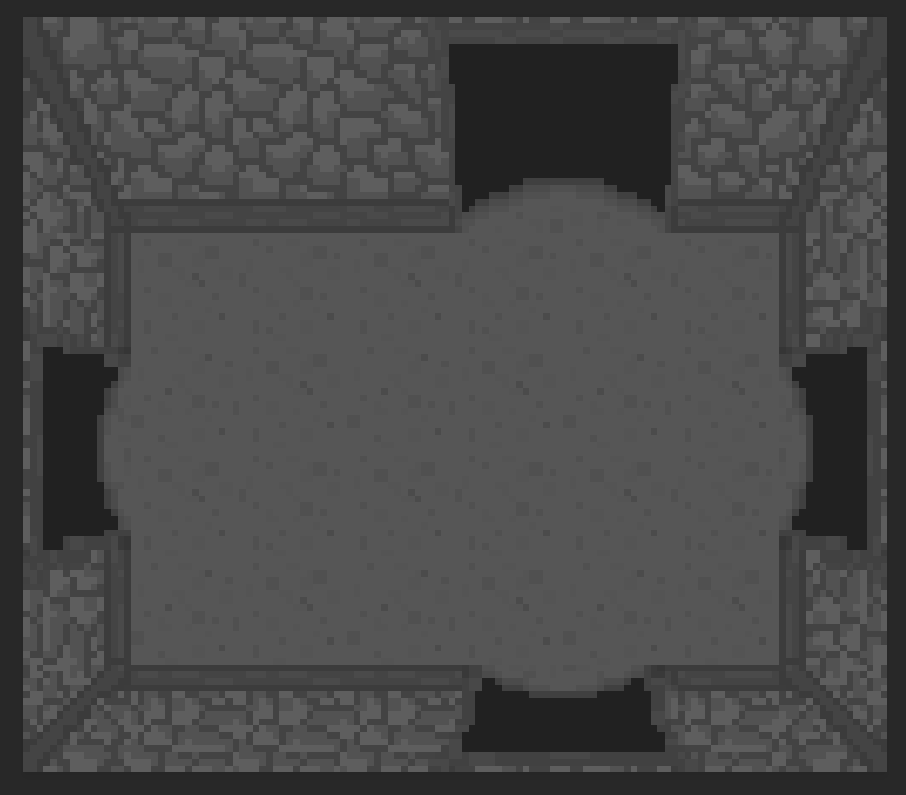

(Not correct ratio)

I wanted the “full” North wall view we see in Enter the Gungeon – it allows for more height in characters versus the squished, more top down view we see in Binding of Isaac. However, I also wanted the one-point perspective towards the center of the screen Binding of Isaac shows to clearly define doors on all walls without the use of null space in our limited space.

To achieve this, I pushed the point in our one-point perspective lower on the screen than we see in Binding of Isaac. It elongates the upper wall considerably while not eliminating our view of the other walls. We have room for our UI elements along the walls where the actors can’t go, and we have a diagetic reason for the limitation – we wanted to ensure enemies couldn’t hide behind the player’s UI elements.

Colors

Next was color palette. In general, I already knew the basics of what would read best, which was reinforced by the research. Darker colors with lower saturation give the ambience we want – a dark dungeon, wrought with danger. A bright color scheme would make this feeling more difficult to pull off. It’s possible, and might be something we explore later – bright greens can give the impression of toxicity, bright reds can summon the image of blood and viscera – but a traditional, earthy color palette will effectively display the simple environment as “mine” or “dungeon” while we focus on animation and character designs.

The background is static per room. Any animation on it will be particles or lighting effects. Static objects shouldn’t draw the player’s attention from the action of the game. Instead, it should play a supporting role in the visuals, a backdrop to what the game is about. If the background is the most memorable aspect of the game, we haven’t done our jobs as designers.

By letting the background be the simple backdrop it needs to be, we can make the other graphics, the animations and characters, memorable and exciting. Dark, desaturated tones allow for the foreground elements to be bright and saturated, easily visible to the player.

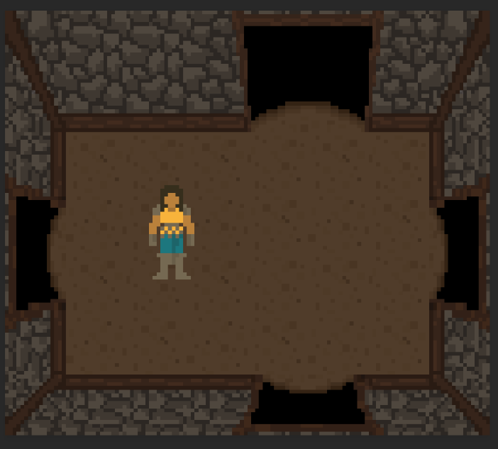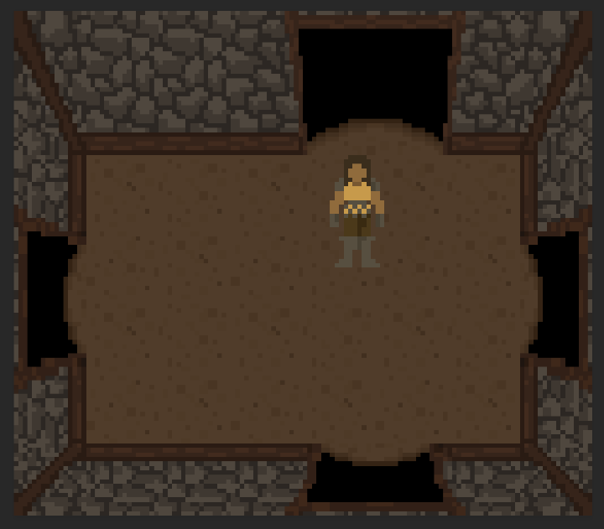

The first (left) character I designed (before the tile set was created) is lighter, and you can see the more saturated yellow is very visible, but in general, they also fall into an earthy palette which forces it into the already earthy background.

Without changing the design of the character, I boosted the saturation and brightness of the character (right). This makes them both more engaging to look at, and causes the character to stand out more against the more dull background. This version rides the edge of being too bright however, the character still needs to look like they exist in this dark, dangerous world – lighting effects will help this as well.

Importing as palette into Unity

This had changed a bit since the last version of Unity I had used.

For the asset settings, I referenced and will likely continue referencing this blog by Eduardo Oriz and Mike Geig:

<https://blogs.unity3d.com/2019/03/13/2d-pixel-perfect-how-to-set-up-your-unity-project-for-retro-8-bits-games/>

For setting up the actual tile map itself, I referenced the official Unity documentation on the subject:

<https://docs.unity3d.com/Manual/Tilemap-CreatingTilemaps.html>